---------------------------------------------------------------------------------------------------------------------
CHAPTER TWO
Circuit Analysis Techniques
-------------------------------------------------------------------------------------------------------------------------------
Basic circuit laws and rules
Ohm's Law
Ohm's Law states that the current in an electric circuit is directly proportional to the applied voltage and inversely proportional to the resistance of the circuit. Three forms of Ohm's Law equations are: I=V/R, V=IR and R=V/I . Therefore Ohm's Law can be used for finding current, voltage drop and resistance in a circuit.
Basic DC electric circuits
Depending on their source of electrical energy, there are two types of electric circuit.
- Dc electric Circuit - is the one with Dc source.
- Ac electric circuit- is the one with an Ac source.
Depending on connection of devices, basically there are three types of circuits:-
- Series connection
- Parallel connection
- Series-Parallel connection

Series circuit
Series Circuit:-In series circuit elements are connected end to end.
There is the same current flowing through all the elements.
The total resistance is the sum of the individual resistances.
The applied voltage is the sum of all the voltage drops.

Fig. 1 series circuit

Mathematically,

RT = R1 + R2 + R3 +……….+RN

Vs = VR1 + VR2 + VR3+…..…+RN

Is = IR1 = IR2 = IR3 =………….=IRN

Voltage Divider Rule

$\begin{aligned}V_{R_{\text{1 }}}=Ι{\text{ R}}_{1}=\frac{V_{s}}{{\text{ R}}_{T}}R_{1}=\frac{R_{1}}{{\text{ R}}_{T}}V_{s} \\ V_{R_{\text{2 }}}=Ι{\text{ R}}_{2}=\frac{V_{s}}{{\text{ R}}_{T}}R_{2}=\frac{R_{2}}{{\text{ R}}_{T}}V_{s} \\ V_{R_{\text{3 }}}=Ι{\text{ R}}_{3}=\frac{V_{s}}{{\text{ R}}_{T}}R_{3}=\frac{R_{3}}{{\text{ R}}_{T}}V_{s}\end{aligned}$States that the amount of voltage drops across each element is directly proportional to the source voltage and resistance value

.

Parallel circuits

Two or more components which are connected to common nodes are said to have a parallel connection.

Parallel circuit:-In a simple parallel circuit

The voltage across each element is the same.

The total current is the sum of the individual branch currents.

Fig. 2 parallel circuit

Mathematically,

Vs = VR1 = VR2 = VR3=………..= VRN

Is + IR1 + IR2 + IR3 =…………. =IRN

Current Divider Rule

States that the amount of current flow across each element is directly proportional to the total current and inversely proportional to the resistance value

$I_{2}=\frac{R_{1}}{R_{1}+R_{2}}Ι_{T}$$I_{1}=\frac{R_{2}}{R_{1}+R_{2}}Ι_{T}$

Series-Parallel circuits
Series- Parallel circuit is a combination of both series and parallel circuits. Therefore it has the property of both series and parallel circuit.
Example for the circuit below calculate total resistor and current flow across each elements If R1=6K , R2=12K, R3=4K, R4=8K, R5=12K
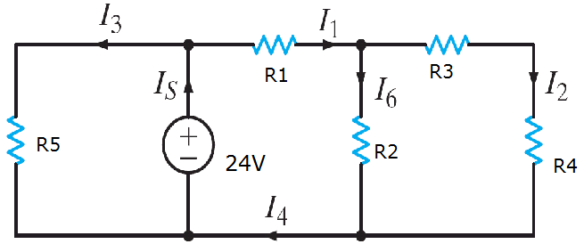

Solution In calculating the required parameters always we have to start from the outer to the source

Thus , R3 +R4 = 4K+8k =12k................R34

R2//R34 = 12k//12k =6k................R234

R234 + R1 = 6k+6k = 12k...........R1234

R1234//R5 = 12k//12k = 6k.................total resistor

Using ohms law, I_{T} =Vs/R_{T} = 24V/6k =4mA ......Total curent

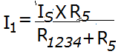
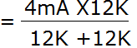
Using CDR

= 2mA......curent across R5 and also across R₁₂₃₄

Again I₁ is further sub divided in to I₆ and I_{2.} To find curent across I₆ and I₂ apply CDR finaly you will got 1mA each.

Kirchhoff’s Current and voltage Laws
Kirchhoff's Current Law (KCL)
It states that the algebraic sum of the currents entering and leaving any junction is zero. In other words, the sum of the currents entering a point is always equal to the sum of the currents leaving.

Mathematically,

Σ I entering a node = Σ I leaving a node

From the above diagram currents I1, I4, I6 are currents entering the node and I2, I3, I5 are currents leaving the node Thus

I₁ + I₃ + I₅ = I₂ +I₄ + I₆
Kirchhoff's Voltage Law (KVL)

It states that the algebraic sum of voltages in a closed loop is zero. In other words the sum the supply voltage in a closed loop is always equal to the sum of the voltage drops

Mathematically,

In a closed loop = 0

From the above circuit

Vs – V₁ – V₂ – V₃ = 0

or -Vs + V₁ + V₂ + V₃ = 0

Vs = V₁ + V₂ + V₃

Delta-Star Transformation of resistor networks

The transformation is used to establish equivalence for networks with 3 terminals. Where three elements terminate at a common node and none are sources, the node is eliminated by transforming the resistances. For equivalence, the resistance between any pair of terminals must be the same for both networks. The equations given here are valid for real as well as complex impedances

Delta - Star Transformation
To convert a Delta network to an equivalent Star network we need to derive a transformation formula for equating the various resistors to each other between the various terminals. Consider the circuit below.
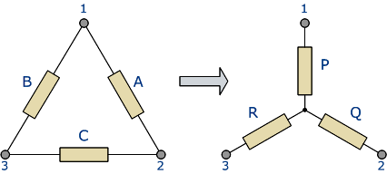
Fig.3 transformation from delta connection of elements(left) to star connection(right)
Compare the resistances between terminals 1 and 2.
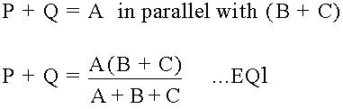
Resistance between the terminals 2 and 3.
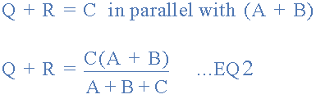
Resistance between the terminals 1 and 3.
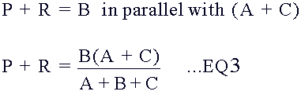

This now gives us three equations and taking equation 3 from equation 2 gives:
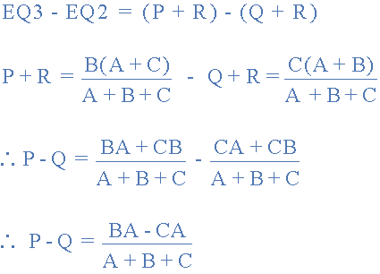
Then, re-writing Equation 1 will give us:
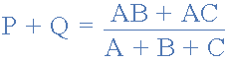
Adding together equation 1 and the result above of equation 3 minus equation 2 gives:
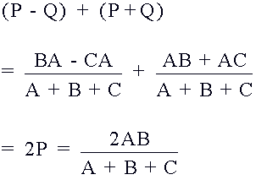
From which gives us the final equation for resistor P as:
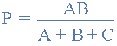
Then to summarize a little the above maths, we can now say that resistor P in a Star network can be found as Equation 1 plus (Equation 3 minus Equation 2) or Eq1 + (Eq3 - Eq2).
Similarly, to find resistor Q in a Star network, is equation 2 plus the result of equation 1 minus equation 3 or Eq2 + (Eq1 - Eq3) and this gives us the transformation of Q as:
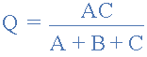
And again, to find resistor R in a Star network, is equation 3 plus the result of equation 2 minus equation 1 or Eq3 + (Eq2 - Eq1) and this gives us the transformation of R as:
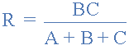
When converting a Delta network into a Star network the denominators of all of the transformation formulas are the same: A + B + C, and which is the sum of ALL the Delta resistances. Then to convert any Delta connected network to an equivalent Star network we can summarized the above transformation equations as:

Delta to star transformation equations

Example
Convert the following Delta Resistive Network into an equivalent Star Network.
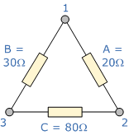 | 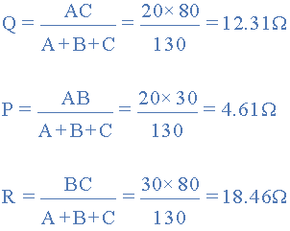
Transformation formulas for converting a resistive Star network to an equivalent Delta network as shown below.

Star to Delta Transformation
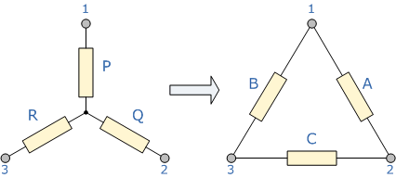
Fig.4 transformation from star connection of elements(left) to delta connection(right)
The value of the resistor on any one side of the Delta, Δ network is the sum of all the two-product combinations of resistors in the Star network divide by the Star resistor located "directly opposite" the Delta resistor being found. For example, resistor A is given as:
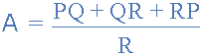
with respect to terminal 3 and resistor B is given as:
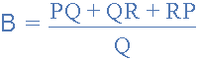
with respect to terminal 2 with resistor C given as:
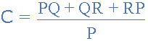
with respect to terminal 1.
By dividing out each equation by the value of the denominator we end up with three separate transformation formulas that can be used to convert any Delta resistive network into an equivalent Star network as given below.
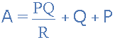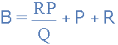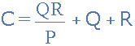
One final point about converting a Star resistive network to an equivalent Delta network - If all the resistors in the Star network are equal in value then the resultant resistors in the equivalent Delta network will be three times the value of the Star resistors and equal, giving: R_{DELTA} = 3R_{STAR}

Mesh (loop) and Nodal Analysis
Mesh (loop) Analysis
Mesh analysis provides a general procedure for analyzing circuits, using mesh currents as the circuit variables. Using mesh currents instead of element currents as circuit variables is convenient and reduces the number of equations that must be solved simultaneously.
A loop is a closed path with no node passed more than once. A mesh is a loop that does not contain any other loop within it. Mesh analysis applies KVL to find unknown currents.

Steps to determine mesh currents
1. Assign mesh currents i₁, i₂. . . i_{n} to the n meshes.
2. Apply KVL to each of the n meshes. Use Ohm’s law to express the voltages in terms of the mesh currents.
3. Solve the resulting n simultaneous equations to get the mesh currents.
Example: Find Vo?

Solution: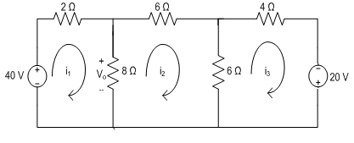
We have 3 meshes (loops)
KVL left loop : $−40+2i_{1}+8\left(i_{1}−i_{2}\right)=0$ why is it -40?
$10i_{1}−8i_{2}+0i_{3}=40$
KVL middle loop : $8\left(i_{2}−i_{1}\right)+6i_{2}+6\left(i_{2}−i_{3}\right)=0$
$−8i_{1}+20i_{2}−6i_{3}=0$
KVL right loop : $20+6\left(i_{3}−i_{2}\right)+4i_{3}=0$
$0i_{1}−6i_{2}+10i_{3}=−20$
Solve the above three equations involving the variables i₁, i₂ and i₃ using simaltaneous solving method. In matrix form the equations can be expressed as
$$\left[\begin{matrix}10 & −8 & 0 \\ −8 & 20 & −6 \\ 0 & −6 & 10\end{matrix}\right]\left[\begin{matrix}i_{1} \\ i_{2} \\ i_{3}\end{matrix}\right]=\left[\begin{matrix}40 \\ 0 \\ −20\end{matrix}\right]$$
Solving the matrix we can find that
$$i_{1}=5.6A,i_{2}=2A,i_{3}=−0.8A$$
$$V_{o}=8\left(i_{1}−i_{2}\right)=8\left(5.6−2\right)=8\left(3.6\right)=28.8V$$
A Supermesh results when two meshes have a (dependent or independent) current source in common. The presence of the current sources in between meshes reduces the number of equations.
Note the following are properties of a supermesh:
1. The current source in the supermesh is not completely ignored; it provides the constraint equation necessary to solve for the mesh currents.
2. A supermesh has no current of its own.
3. A supermesh requires the application of both KVL and KCL.
Example:
For the circuit in Fig. below, find i₁ to i₄ using mesh analysis.
Solution:
Note that meshes 1 and 2 form a supermesh since they have an independent current source in common. Also, meshes 2 and 3 form another supermesh because they have a dependent current source in common. The two supermeshes intersect and form a larger supermesh as shown. Applying KVL to the larger supermesh,

Applying KVL on the supermesh,
$$2i_{1}+4i_{3}+8\left(i_{3}−i_{4}\right)+6i_{2}=0$$
$$i_{1}+3i_{2}++6i_{3}−4i_{4}=0$$
For the independent current source we apply KCL to node P:
$$i_{2}=i_{1}+5$$
For the dependent current source we apply KCL to node Q:
$$i_{2}=i_{3}+{3i}_{o}$$
But $i_{o}=−i_{4}$ , hence
$$i_{2}=i_{3}−3i_{4}$$
Applying KVL in mesh 4,
$${2i}_{4}+8\left(i_{4}−i_{3}\right)+10=0$$
$${5i}_{4}−4i_{3}=−5$$
From the equations above we can solve to find
$$i_{1}=−7.5Ai_{2}=−2.5Ai_{3}=3.93Ai_{4}=2.143A$$

Nodal Analysis
Nodal analysis provides a general procedure for analyzing circuits using node voltages as the circuit variables. Choosing node voltages instead of element voltages as circuit variables is convenient and reduces the number of equations one must solve simultaneously. In nodal analysis, we are interested in finding the node voltages.
Steps to determine node voltages:
1. Select a node as the reference node. Assign voltages v₁, v₂, . . . , v_{n−1} to the remaining n − 1 nodes. The voltages are referenced with respect to the reference node.
2. Apply KCL to each of the n − 1 nonreference nodes. Use Ohm’s law to express the branch currents in terms of node voltages.
3. Solve the resulting simultaneous equations to obtain the unknown node voltages.
The first step in nodal analysis is selecting a node as the reference or datum node. The reference node is commonly called the ground since it is assumed to have zero potential. We then apply KCL at each node applying Ohm’s law to express the unknown currents i₁, i₂, i₃… in terms of node voltages.
The key idea to bear in mind when expressing the unknown currents in terms of node voltages is that, Current flows from a higher potential to a lower potential in a resistor.
We can express this principle as
$$i=\frac{v_{higher}−v_{lower}}{R}$$
Example :- find the voltages at node 1 and 2
Essential nodes are: 1,2,3
Consider node 3 to be the reference node (ground)
Applying KCL at node 1
$$i_{1}−i_{2}−i_{3}=0$$
$$\frac{V_{m}−V_{1}}{R_{1}}−\frac{V_{1}}{R_{2}}−\frac{V_{1}−V_{2}}{R_{3}}=0$$
$$\frac{10−V_{1}}{2}−\frac{V_{1}}{1}−\frac{V_{1}−V_{2}}{2}=0$$
$$5−\frac{V_{1}}{2}−V_{1}−\frac{V_{1}}{2}+\frac{V_{2}}{2}=0$$
$$5−2V_{1}+\frac{V_{2}}{2}=0$$
$$4V_{1}−V_{2}=10$$
Apply KCL at node 2,
$$i_{3}−i_{4}−i_{5}=0$$
$$\frac{V_{1}−V_{2}}{R_{3}}−\frac{V_{2}}{R_{4}}−\frac{V_{2}−V_{n}}{R_{5}}=0$$
$$\frac{V_{1}−V_{2}}{2}−\frac{V_{2}}{2}−\frac{V_{2}+5}{1}=0$$
$$\frac{V_{1}}{2}−2V_{2}−5=0$$
$$V_{1}−{4V}_{2}=10$$
Using the equations from the two nodes we can solve simultaneously or using matrixes
$$\left[\begin{matrix}4 & −1 \\ 1 & −4\end{matrix}\right]\left[\begin{matrix}V_{1} \\ V_{2}\end{matrix}\right]=\left[\begin{matrix}10 \\ 10\end{matrix}\right]$$
$$AV=B=V=A^{−1}B$$
$${V_{1}=2∧V}_{2}=−2$$
Special case:
What if a branch between two essential non-reference nodes contains a voltage source? This case is called “super node" case.
Find Io
- Number of essential nodes =N=3
- Super node : is the voltage source and the two connecting nodes
- Number of equations = N-1-1 = 3-1-1= 1, first 1 subtracted for reference node second 1 for super node
But we need two equations to solve for two unknowns => there is an equation that describes the super node and we use that equation.
Applying KCL at the super node:
$$i_{1}+i_{2}+i_{3}+I_{o}=0$$
$$\frac{V_{1}}{12k}+\frac{V_{1}}{12k}+\frac{V_{2}}{12k}+\frac{V_{2}}{12k}=0$$
$$\frac{V_{1}}{6k}+\frac{V_{2}}{6k}=0$$
The super node is described by the equation
$$V_{2}+6=V_{1}$$
We have two equations with two unknowns, solving the equations using simultaneous solving or matrix
$$\left[\begin{matrix}\frac{1}{6k} & \frac{1}{6k} \\ 1 & −1\end{matrix}\right]\left[\begin{matrix}V_{1} \\ V_{2}\end{matrix}\right]=\left[\begin{matrix}0 \\ 6\end{matrix}\right]$$
$$V_{1}=3V$$
$$V_{2}=−3V$$
$$>I_{o}=\frac{V_{2}}{12k}=\frac{−3}{12k}=−0.25mA$$
The negative sign implies that the actual current direction is the opposite of what was assumed at the start of the analysis.

2.5. Linearity and Superposition Theorem
Linearity
Linearity is the property of an element describing a linear relationship between cause and effct. It is a combination of both homogeneity (scaling) property and the additivity property. The homogeneity property requires that if input also called excitation is multiplied by a constant, then the output also called the response is multiplied by the same constant. The additivity property requires that the response to a sum of inputs is the sum of the responses to each input applied separately.
Mathematically, given a function$y=f\left(x\right)$ , and $y_{1}=f\left(x_{1}\right)$ & $y_{2}=f\left(x_{2}\right)$ , the function $f\left(x\right)$ is said to be linear if and only if $f\left({a_{1}x}_{1}+{a_{2}x}_{2}\right)={a_{1}y}_{1}+{a_{2}y}_{2}$ for any two inputs$x_{1}$ and $x_{2}$and any constants $a_{1}$ and $a_{2}$. This property of the function is said to be property of linearity.
Example: Is the power dissipated by a resistor a linear function of current?
Soln: $p=f\left(i\right)=i^{2}R$
$p_{1}=i_{1}^{2}R$
$p_{2}=i_{2}^{2}R$
$f\left({a_{1}i}_{1}+{a_{2}i}_{2}\right)={\left(a | | 1i | | 1+{a_{2}i}_{2}\right)}^{2}$R
$a_{1}^{2}i_{1}^{2}R+2{a_{1}{a_{2}i}_{1}i}_{2}R+a_{2}^{2}i_{2}^{2}R$
$$≠{a_{1}p}_{1}+{a_{2}p}_{2}$$
Therefore, the power dissipated in a resistor is not linear function of current. It can also be shown in the same way that power dissipated in a resistor is not linear function of voltage.
Show that Ohm’s Law satisfies linearity property; Thus a resistor is a linear circuit element.
An electrical circuit is said to be linear if its outputs are linearly related (or directly proportional) to its inputs. A linear circuit consists of only linear elements, linear dependent sources and independent sources.
Superposition Theorem
If a circuit has two or more independent sources, the value of a specific variable can be determined by adding the contribution of each independent source to the variable. This approach is known as superposition and it is based on the property of linearity. This theorem can be stated as:
The current through or the voltage across an element in a linear network is equal to the algebraic sum of the currents or the voltages produced independently by each source.
The effect of each source is considered independently by removing and replacing the other sources without affecting the final result. To remove a voltage source when applying this theorem, the difference in potential between the terminals of the voltage source must be set to zero (short circuit); removing a current source requires that its terminals be opened (open circuit). The internal resistances associated with the removed sources are not eliminated but must still be considered. This is illustrated in fig.2.5.
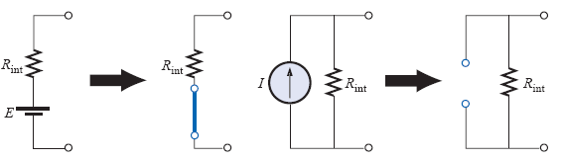
Fig.2.5 Removing the effects of practical sources
As stated earlier, the total current through any portion of the circuit is equal to the algebraic sum of the currents produced independently by each source. If the current produced by one source is in one direction, while that produced by the other is in the opposite direction through the same resistor, the resulting current is the difference of the two and has the direction of the larger. If the individual currents are in the same direction, the resulting current is the sum of two in the direction of either current. This rule holds true for the voltage across a portion of a circuit as determined by polarities, and it can be extended to circuits with any number of sources. The superposition principle is not applicable to power effects since the power loss in a resistor varies as the square (nonlinear) of the current or voltage, as proved previously.

Example: 1. In the circuit below, apply superposition theorem to find $v_{0}$ in terms of $V_{S}$ and $I_{S}$.
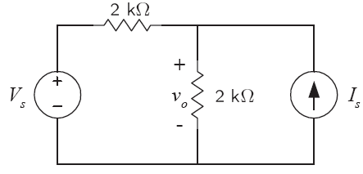
Soln:
First find the contribution due to the source $V_{S}$. This means the current source us turned off by making an open circuit. This is shown below.
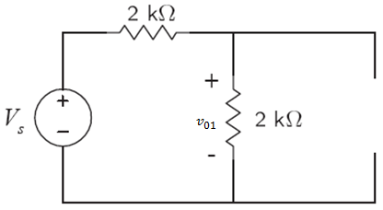

By VDR, $v_{01}=\frac{2}{2+2}V_{S}=\frac{1}{2}V_{S}$
Now find the contribution due to the source $I_{s}$.
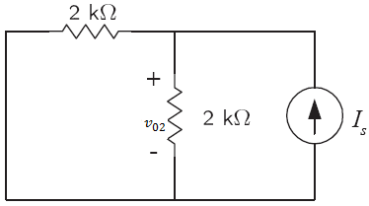

By applying CDR and then Ohm’s Law, $v_{02}=2\left(\frac{2}{2+2}I_{s}\right)=I_{S}$.
Therefore, by the superposition theorem, the voltage

$$v_{0}=v_{01}+v_{02}=\frac{1}{2}V_{S}+I_{S}$$

Example: Use the principle of superposition to find $v_{0}$.

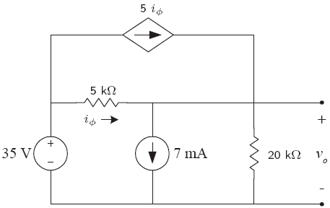

Soln: First solve for $v_{0}$ with the 35V source turned off. To turn off voltage source, it is replaced by a short circuit as shown in the following figure in which also the loops are indicated to use mesh analysis to obtain the contribution of the independent current source to the voltage$v_{0}$. Applying mesh theorem,

$I_{1}=5i_{ϕ}$
$I_{2}=7$
$I_{2}+I_{3}−I_{1}=i_{ϕ}$
$5i_{ϕ}+{20I}_{3}=0$ ....................KVL on mesh$I_{3}$.

Solving the above four equations simultaneously, $I_{3}=−0.28mA$.
By applying Ohm’s Law,${v_{01}=20I}_{3}=20×\left(−0.28\right)=−5.6V$.
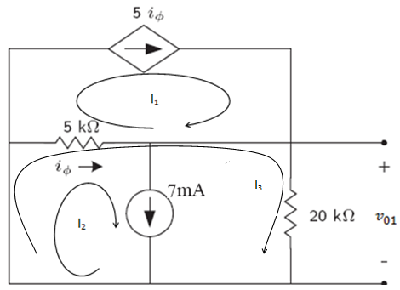
Now the contribution of the voltage source can be found by turning off (open circuiting) the independent current source.
Applying KCL at node A,
$5i_{ϕ}+i_{ϕ}=I$
Using Ohm’s Law,$i_{ϕ}=\frac{35−v_{02}}{5}$ and $I=\frac{v_{02}}{20}$.
Solving the above equations, $v_{01}=33.6V$.
Therefore, by superposition theorem, the voltage $v_{0}=v_{01}+v_{02}=−5.6+33.6=28V$.
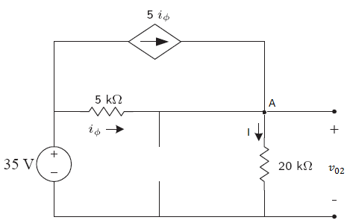

Source transformation
A transformation that allow a voltage source in series with a resistor to be replaced by a current source in parallel with the same resistor or vice versa.

(a) (b)
Fig. 2.6 Circuits with Equivalent voltage source and current source with their respective resistance connection
We need to find I_{s} and V_{s} such that V_{L} and I_{L} is the same in both circuits

In ckt 1 ,
$$I_{L}=\frac{V_{S}}{R_{L}+R}$$
In ckt 2 ,
$$I_{L}=\frac{R}{R_{L}+R}I_{S}$$
For I_{L} to be the same, we need
$$V_{S}=RI_{S}$$
<=>

Fig. 2.7 voltage source$V_{S}$ transformed to current source$I_{S}$
Where
$$V_{S}=RI_{S}∨I_{S}=\frac{V_{S}}{R}$$

Example : Use source transformation to find V_{O}
Transform the two voltage sources in series with their respective resistances to current sources with parallel resistance
$$i_{2}=\frac{R_{1}}{R_{1}+R_{2}+R_{3}}i=\frac{2.4}{2.4+1.6+8}\left(30\right)=6A$$
$$V_{O}=i_{2}R_{3}=\left(6A\right)\left(8Ω\right)$$
$$V_{O}=48V$$

Exersise : Using source transformation find the power associated with the 6 V source.

2.6. Thevenin’s and Norton’s Theorems
Before stating these two theorems, it is important to introduce the principle of source transformation. Source transformation helps to simplify circuits. Its concept is based on the concept of equivalence. Two circuits are equivalent if the voltage-current relationships are the same at their terminals.
A source transformation is the process of replacing a voltage source$V_{S}$ in series with a resistor R by a current source $I_{S}$ in parallel with a resistor R, or vice versa. Fig. 2.8 shows the transformation. Note that the arrow of the current source is directed toward the positive terminal of the voltage source. It can be shown that for the two circuits to be equivalent, $V_{S}=I_{S}R$. Hence, source transformation requires that,
$V_{S}=I_{S}R$ or $I_{S}=\frac{V_{S}}{R}$
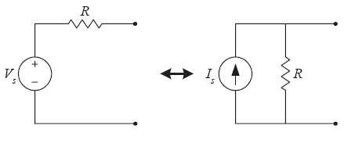
Fig. 2.8 Source transformation
Source transformation can also be applied to dependent sources provided that we carefully handle the dependent variable.

Thevenin’s Theorem
It is often occurs in practice that a particular element in a circuit is variable (usually called load) while the other elements are fixed. In this case, each time the variable element is changed, the entire circuit has to be analyzed all over again. This problem can be avoided using Thevenin’s theorem that provides a technique by which the fixed part of the circuit is replaced by an equivalent circuit.
Thevenin’s theorem states that any two-terminal linear circuit can be replaced by an equivalent circuit consisting of a voltage source $V_{Th}$and a series resistor$R_{Th}$.
The box in fig. 2.9 (left side) contains a linear circuit having two terminals available to the outside world. Using Thevenin’s theorem, it is possible to replace everything in the box with one source and a series resistor as shown on the right, maintaining the same terminal characteristics. The circuit shown on the right of Fig. 2.9 is called Thevenin’s equivalent circuit.
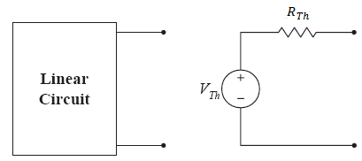
Fig. 2.9 Replacing a linear two-terminal circuit by its Thevenin’s equivalent circuit
How to find the Thevenin’s equivalent voltage $V_{Th}$ and resistance$R_{Th}$? Since the two circuits in Fig. 2.9 are equivalent, they have the same voltage-current relationship at their terminals. This means, the open circuit voltage of the linear circuit must be equal to the Thevenin’s voltage. Again since the two circuits are equivalent, with all independent sources turned off, the input resistance at the terminals of the linear circuit must be equal to$R_{Th}$.
To apply this idea in finding the Thevenin’s resistance, two cases can be considered. First if the linear circuit has no dependent sources, then all independent sources are turned off and $R_{Th}$ is the input resistance of the circuit looking between the terminals. Second, if the linear circuit has dependent sources, all independent sources are turned off. However, as with the superposition theorem, dependent sources are not turned off because they are controlled by circuit variables. We apply a voltage source $V$ or current source $I$ at the terminals and determine the resulting current$I$ or the voltage $V$ as shown in Fig. 2.10. Then $R_{Th}=\frac{V}{I}$ .
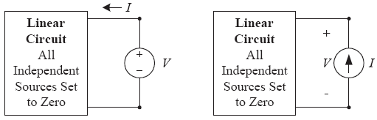
Fig. 2.10 Finding $R_{Th}$ when circuit has dependent source
The following sequence of steps summarize how to obtain proper value of $V_{Th}$ and$R_{Th}$.

- Remove that portion of the circuit across which the Thevenin’s equivalent circuit is to be found. This requires that the load resistor be temporarily removed from the circuit.

- Calculate $R_{Th}$ by first setting all independent sources to zero (voltage sources are replaced by short circuits and current sources by open circuits) and then by finding the resultant resistance between the two terminals. (If the internal resistance of the voltage and/or current sources is included in the original network, it must remain when the sources are set to zero.). Use the method described above if the circuit consists of dependent sources.

- Calculate $V_{Th}$ by first returning all independent sources to their original position and finding the open-circuit voltage between the terminals.

- Draw the Thevenin’s equivalent circuit with the portion of the circuit previously removed replaced between the terminals of the equivalent circuit.

Norton’s Theorem
Norton’s theorem states that any linear circuit can be represented by an equivalent circuit, called Norton’s Equivalent circuit, composed of a current source in parallel with a resistance. This theorem can be obtained from Thevenin’s theorem by source transformation. Fig. 2.11 shows Norton’s equivalent circuit obtained from the corresponding Thevenin’s equivalent circuit. Note that the Norton’s resistance R_{N} is equal to the Thevenin’s resistance R_{Th} and the Norton’s current $I_{N}$is the short circuit current between the terminals where the load removed. It can also be obtained by dividing Thevenin’s voltage by Thevenin’s resistance, as obvious from source transformation.
i.e.; $R_{N}=R_{Th}$ and$I_{N}=\frac{V_{Th}}{R_{Th}}$.
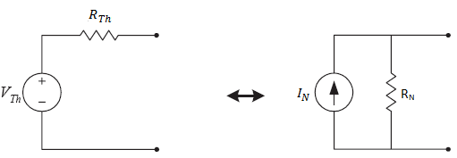
- Thevenin’s Equivalent circuit (b) Norton’s Equivalent circuit
Fig. 2.11 Obtaining Norton’s Equivalent circuit from Thevenin’s Equivalent circuit using source transformation method
Examples:1. Use the Thevenin’s theorem to find V_{o} in the network below. 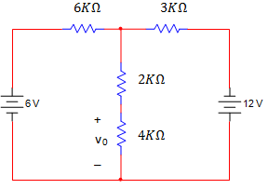
Soln:- Breaking the network at 4 kΩ load, the open circuit voltage can be obtained from the following figure.
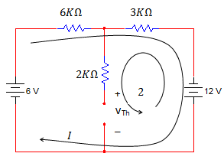
Writing mesh equation for loop I,
$−6+\left(6+3\right)I−12=0$$⇒$$I=2mA$
Then, the open circuit voltage V_{oc} is obtained by writing KVL as follow for loop 2.
$V_{Th}+12−3kΩ∗2mA=0$ {No current flows in 2k Ω load }
$⇒$$V_{Th}=−6V$
R_{Th} is derived from the following network.
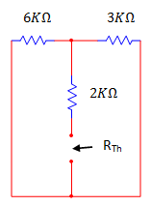

$\begin{aligned}R_{\text{Th}}=2KΩ+(\text{6K}Ω‖\text{3K}Ω) \\ ⇒R_{\text{Th}}=4KΩ\end{aligned}$

Therefore, Thevenin’s equivalent circuit is drawn below, attaching the load to it.
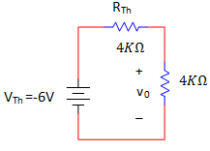
Finally using voltage division,
$\begin{aligned}V_{o}=\left(\frac{V_{\text{Th}}}{4KΩ+R_{\text{Th}}}\right)∗4KΩ=\left(\frac{−6}{4KΩ+4KΩ}\right)∗4KΩ \\ ⇒V_{o}=\underline{\underline{−3V}}\end{aligned}$
2. Find V_{o} in the network below using Norton’s theorem.
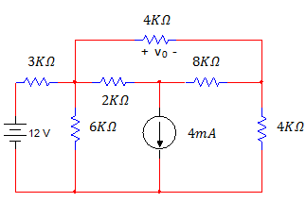
Soln: In applying Norton’s theorem, we must find the short circuit current shown below.
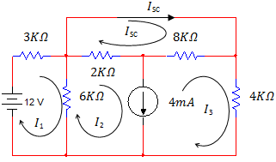
The mesh equations for the above network are
$\begin{aligned}\text{12}=9I_{1}−6I_{2}−−−−−−−−−−−−−−−−−−−−−−−−−−−−−−−−−−\left(1\right) \\ I_{2}−I_{3}=4−−−−−−−−−−−−−−−−−−−−−−−−−−−−−−−−−−−\left(2\right) \\ \text{10}I_{\text{sc}}−2I_{2}−8I_{3}=0−−−−−−−−−−−−−−−−−−−−−−−−−−−−−−\left(3\right)\end{aligned}$
Since there are four unknowns we need additional equation, and we can obtain it from KVL around external loop.
$\text{12}=3I_{1}−4I_{3}−−−−−−−−−−−−−−−−−−−−−−−−−−−−−−−−−−\left(4\right)$
Solving the above equations simultaneously, we obtain
$\begin{aligned}I_{1}=4\text{mA} \\ I_{2}=4\text{mA} \\ I_{3}=0\text{mA} \\ I_{\text{sc}}=\underline{\underline{\frac{4}{5}\text{mA}}}\end{aligned}$and
$I_{\text{sc}}$ is obtained. But to obtain Norton’s equivalent circuit, the Thevenin’s equivalent resistance has to be obtained from the following network.
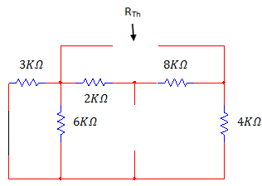
$$\begin{aligned}⇒R_{\text{Th}}=\left(3KΩ‖6KΩ+4KΩ\right)‖\left(2KΩ+8KΩ\right) \\ ∴R_{\text{Th}}=6KΩ‖\text{10}KΩ=\frac{6∗\text{10}}{\text{10}+6}=\frac{6∗\text{10}}{\text{16}}KΩ \\ ⇒\underline{\underline{R_{\text{Th}}=\text{15}4kΩ}}\end{aligned}$$
Hence, the Norton’s equivalent circuit with the load connected is
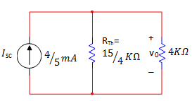
$$\begin{aligned}∴\text{vo}=\frac{4}{5}\text{mA}∗\left(\frac{\text{15}}{4}KΩ‖4KΩ\right)=\frac{\frac{4}{5}∗\left(\text{15}4∗4\right)}{\text{15}4+4}V \\ {}^{}{}^{}=\left(\frac{\text{12}}{\text{31}}\right)\underline{\underline{4V=\frac{\text{48}}{\text{31}}V}}\end{aligned}$$
- Find v₀ in the network below using Thevenin’s theorem.
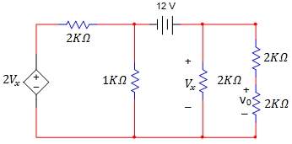

Soln:-We can break the network removing the two right most resistors.
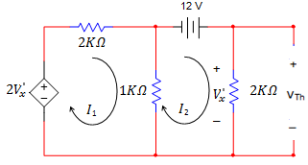

Writing mesh equations
$\begin{aligned}3I_{1}−I_{2}=2V_{x}^{'}−−−−−−−−−−−−−−−−−−−−−−−−−−−−−−−−−−(1) \\ −I_{1}+3I_{2}=\text{12}−−−−−−−−−−−−−−−−−−−−−−−−−−−−−−−−−−(2) \\ V_{x}^{'}=2I_{2}−−−−−−−−−−−−−−−−−−−−−−−−−−−−−−−−−−−−−(3)\end{aligned}$
Solving the above three equations simultaneously
$I_{1}=\text{15}\text{mA},{}^{}{}_{}I_{2}=9\text{mA}\underset{}{}{}_{}{}_{}\text{and}{}_{}{}_{}V_{x}^{'}=\text{18}V$
The Thevenin’s voltage V_{Th} is
$\underline{\underline{V_{\text{Th}}=V_{x}^{'}=\text{18}V}}$
The following circuit is used to get short circuit current.
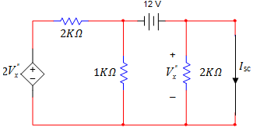
The presence of short- circuit forces the current in the right 2kΩ resistor to zero- hence the voltage $V_{x}^{\text{\} \} \} \{}}$across it is zero and the circuit reduces to
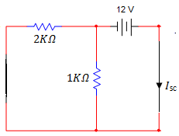
$\begin{aligned}∴I=\frac{\text{12}V}{\left(2KΩ‖1KΩ\right)}=\left(\frac{\text{12}}{23}\right)\text{mA} \\ ⇒\underline{\underline{I_{\text{sc}}=\text{18}\text{mA}}}\end{aligned}$
Therefore, the Thevenin’s equivalent resistance is
$\begin{aligned}R_{\text{Th}}=\frac{V_{\text{Th}}}{I_{\text{sc}}}=\frac{\text{18}V}{\text{18}\text{mA}} \\ ⇒\underline{\underline{R_{\text{Th}}=1kΩ}}\end{aligned}$
Hence Thevenin’s equivalent circuit with network containing the load attached to it is.
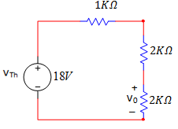

Now, using voltage division rule,
$\begin{aligned}V_{o}=\left(\frac{\text{18}}{1+2+2}\right)∗2V \\ {{}_{{}_{}}}_{}=\left(\frac{\text{18}}{5}\right)∗2=\frac{\text{36}}{5}V \\ ⇒\underline{\underline{V_{o}=7\text{.}2V}}\end{aligned}$

2.7. Maximum power transfer
We can determine the maximum power that a circuit can supply and a manner in which to adjust the load to effect maximum power transfer by using Thevenin’s theorem.
Given the circuit shown below.
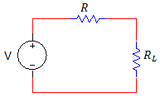
The power that is delivered to the load is given by the expression.
$P_{L}=i^{2}R_{L}$ $\text{but}{{{}_{}}_{}}_{}i=\frac{V}{R+R_{L}}$
$⇒P_{L}={\left(\frac{V}{R+R_{L}}\right)}^{2}R_{L}$
We want to determine the value of R_{L} that maximizes the power. Therefore, differentiating this expression with respect to the load resistor R_{L,} and equating the derivative to zero, we can obtain the value of R_{L} for which the power becomes maximized.
$\begin{aligned}\frac{{\text{dp}}_{L}}{{\text{dR}}_{L}}=\frac{V^{2}}{{\left(R+R_{L}\right)}^{2}}−\frac{2R_{L}\left(R+R_{L}\right)V^{2}}{{\left(R+R_{L}\right)}^{4}}=0 \\ ⇒V^{2}\frac{\left[{\left(R+R_{L}\right)}^{2}−2R_{L}\left(R+R_{L}\right)\right]}{{\left(R+R_{L}\right)}^{4}}=0 \\ ⇒R+R_{L}−2R_{L}=0 \\ ⇒R_{L}=R\end{aligned}$
Therefore, maximum power transfer takes place when the load resistance R_{L}= R. The voltage source V and the resistance R could represent the voltage and the resistance in Thevenin’s equivalent circuit for any linear network.
$P_{L\underset{}{}\text{max}}=\left(\frac{V}{R+R_{L}}\right)R_{L}|_{R=R_{L}}=\frac{V^{2}}{4R_{L}}$ Then, the max power transferred is

Examples: Find the value of R₂ for maximum power transfer in the network below and the maximum power that can be transferred to this load.
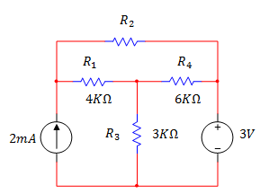
Soln:- First obtain Thevenin’s equivalent circuit for the network exclusive of the load (resistor R₂).
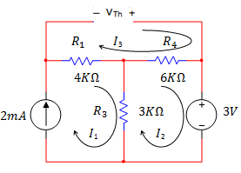
Using mesh analysis to obtain V_{Th}:
KVL across loop I₃,
$V_{\text{Th}}=4KΩI_{1}+6KΩI_{2}$
$\text{but}{}_{{}_{}}\underline{\underline{I_{1}=2\text{mA}}}$ and by KVL across loop I₂,
$\begin{aligned}6KΩI_{2}+3V+3KΩ\left(I_{2}−I_{1}\right)=0 \\ ⇒6KΩI_{2}+3V+3KΩI_{2}−3KΩI_{1}=0 \\ ⇒9KΩI_{2}=3KΩ∗2\text{mA}−3V=3V \\ \underline{\underline{I_{2}=13}}\text{mA}\end{aligned}$
$\begin{aligned}∴V_{\text{Th}}=4KΩ∗2\text{mA}+6KΩ∗13\text{mA} \\ {}^{}{}_{\underset{}{}}=8+2=\underline{\underline{\text{10}V}}\end{aligned}$
To obtain R_{Th} consider the following circuit should be considered where the current source is turned off by open circuiting, and the voltage source is turned off by short circuiting.
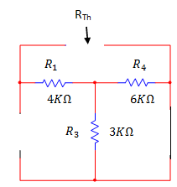
From the previous circuit
$\begin{aligned}R_{\text{Th}}=4KΩ+6KΩ‖3KΩ \\ {}_{}{}_{}=4KΩ+\frac{6KΩ∗3KΩ}{6KΩ+3KΩ} \\ ⇒\underline{\underline{R_{\text{Th}}=6KΩ}}\end{aligned}$
Therefore, the Thevenin’s equivalent circuit is
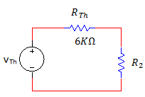
For maximum power transfer R_{L} = R_{Th}.
$$∴R\underline{\underline{{}_{L}=R_{\text{Th}}=6KΩ}}$$
Maximum power transferred to the load is
$$\begin{aligned}P_{L}={\left(\frac{V_{\text{oc}}}{R_{\text{Th}}+R_{L}}\right)}^{2}R_{L}={\left[\frac{\text{10}V}{\left(6KΩ+6KΩ\right)}\right]}^{2}∗\left(6KΩ\right) \\ {}_{}{}_{}=\frac{{\text{10}}^{2}}{4∗6}∗{\text{10}}^{−3}W=\underline{\underline{\frac{\text{25}}{6}\text{mW}}}\end{aligned}$$

